National Textile University, Faisalabad


Department of Computer Science

Name: | Muhammad Ali Akram
Class: | BSCS-5th-B
Registration No: | 23-NTU-CS-1062
Course Name: | Embedded IoT
Submitted To: | Sir Nasir
Submission Date: | October 26, 2025

Code:
#include <Arduino.h>
#include <Wire.h>
#include <Adafruit_GFX.h>
#include <Adafruit_SSD1306.h>

// =================== OLED SETUP ===================
#define SCREEN_WIDTH 128
#define SCREEN_HEIGHT 64
#define OLED_ADDR 0x3C
Adafruit_SSD1306 display(SCREEN_WIDTH, SCREEN_HEIGHT, &Wire, -1);

// =================== TASK A PINS ===================
#define LED1 19 // LED 1
#define LED2 18 // LED 2
#define BTN_MODE 26 // Button to cycle modes
#define BTN_RESET 0 // Onboard BOOT button (reset to OFF)

// =================== TASK B PINS ===================
#define LED3 17 // Single LED for Task B
#define BTN_EVENT 25 // Button for short/long press
#define BUZZER_PIN 32 // Buzzer pin

// =================== PWM SETTINGS ===================
#define PWM_CH_LED1 0
#define PWM_CH_LED2 1
#define PWM_CH_BUZZER 2
#define PWM_FREQ 5000
#define PWM_RES 10 // 10-bit (0–1023)

// =================== VARIABLES ===================
// ---- Task A ----
int mode = 0; // 0=OFF, 1=Blink, 2=ON, 3=Fade
bool ledState = false;
unsigned long prevMillisBlink = 0;
int fadeVal = 0;
int fadeDir = 10;
unsigned long lastDebounce = 0;
const int debounceDelay = 300;

// ---- Task B ----
bool pressed = false;
unsigned long pressStart = 0;
bool led3State = false;
bool buzzerActive = false;

// =================== OLED FUNCTION ===================
void showOLED(const String &line1, const String &line2 = "") {
display.clearDisplay();
display.setTextSize(2);
display.setTextColor(SSD1306_WHITE);
display.setCursor(0, 5);
display.print(line1);
display.setTextSize(1);
display.setCursor(0, 40);
display.print(line2);
display.display();
}

// =================== SETUP ===================
void setup() {
Serial.begin(115200);

// ---- OLED ----
Wire.begin(21, 22);
if (!display.begin(SSD1306_SWITCHCAPVCC, OLED_ADDR)) {
Serial.println("OLED init failed!");
for (;;);
}
showOLED("System", "Initializing...");
delay(1000);

// ---- LEDs and Buttons ----
pinMode(LED1, OUTPUT);
pinMode(LED2, OUTPUT);
pinMode(LED3, OUTPUT);
pinMode(BTN_MODE, INPUT_PULLUP);
pinMode(BTN_RESET, INPUT_PULLUP);
pinMode(BTN_EVENT, INPUT_PULLUP);

// ---- PWM Setup ----
ledcSetup(PWM_CH_LED1, PWM_FREQ, PWM_RES);
ledcSetup(PWM_CH_LED2, PWM_FREQ, PWM_RES);
ledcSetup(PWM_CH_BUZZER, PWM_FREQ, PWM_RES);

ledcAttachPin(LED1, PWM_CH_LED1);
ledcAttachPin(LED2, PWM_CH_LED2);
ledcAttachPin(BUZZER_PIN, PWM_CH_BUZZER);

// ---- Start in Mode 0 (OFF) ----
ledcWrite(PWM_CH_LED1, 0);
ledcWrite(PWM_CH_LED2, 0);
showOLED("Mode 1", "Both OFF");
}

// =================== LOOP ===================
void loop() {
unsigned long now = millis();

// ===================== TASK A =====================
bool btnMode = digitalRead(BTN_MODE);
bool btnReset = digitalRead(BTN_RESET);

// ---- Mode Button (Cycle) ----
if (btnMode == LOW && (now - lastDebounce > debounceDelay)) {
lastDebounce = now;
mode = (mode + 1) % 4;
switch (mode) {
case 0: showOLED("Mode 1", "Both OFF"); break;
case 1: showOLED("Mode 2", "Alt Blink"); break;
case 2: showOLED("Mode 3", "Both ON"); break;
case 3: showOLED("Mode 4", "PWM Fade"); break;
}
}

// ---- Reset Button (BOOT) ----
if (btnReset == LOW && (now - lastDebounce > debounceDelay)) {
lastDebounce = now;
mode = 0;
showOLED("Mode 1", "Reset to OFF");
}

// ---- LED Control ----
switch (mode) {
case 0: // Both OFF
ledcWrite(PWM_CH_LED1, 0);
ledcWrite(PWM_CH_LED2, 0);
break;

case 1: // Alternate blink
if (now - prevMillisBlink >= 500) {
prevMillisBlink = now;
ledState = !ledState;
ledcWrite(PWM_CH_LED1, ledState ? 512 : 0);
ledcWrite(PWM_CH_LED2, ledState ? 0 : 512);
}
break;

case 2: // Both ON
ledcWrite(PWM_CH_LED1, 512);
ledcWrite(PWM_CH_LED2, 512);
break;

case 3: // PWM fade
ledcWrite(PWM_CH_LED1, fadeVal);
ledcWrite(PWM_CH_LED2, fadeVal);
fadeVal += fadeDir;
if (fadeVal <= 0 || fadeVal >= 1023) fadeDir = -fadeDir;
delay(5);
break;
}

// ===================== TASK B =====================
bool btnEvent = digitalRead(BTN_EVENT);

if (btnEvent == LOW && !pressed) {
pressed = true;
pressStart = now;
buzzerActive = false;
}

if (pressed && btnEvent == LOW) {
// Button is being held
unsigned long holdTime = now - pressStart;
if (holdTime > 1500 && !buzzerActive) {
// ---- Long press detected (while holding) ----
showOLED("Long Press", "Buzzer Tone");
ledcWriteTone(PWM_CH_BUZZER, 1000);
buzzerActive = true;
Serial.println("Long press started - buzzer active");
}
}

if (btnEvent == HIGH && pressed) {
// Button released
pressed = false;

if (!buzzerActive) {
// ---- Short press ----
led3State = !led3State;
digitalWrite(LED3, led3State);
showOLED("ShortPress", led3State ? "LED3 ON" : "LED3 OFF"); // fixed wrapping
Serial.println("Short press detected.");
} else {
// ---- Stop buzzer when released ----
ledcWrite(PWM_CH_BUZZER, 0);
buzzerActive = false;
Serial.println("Long press released - buzzer stopped");
}
}
}

Pin Map:
Component | Pin (GPIO)
OLED Display | SDA: 21 / SCL: 22
Task A
LED 1 (Cyan) | 19
LED 2 (Green) | 18
Mode Button | 26
Reset Button | 0 (On-Board BOOT Button)
Task B
LED 3 | 17
Event Button | 25
Buzzer | 32

Screenshots:

Initializing:
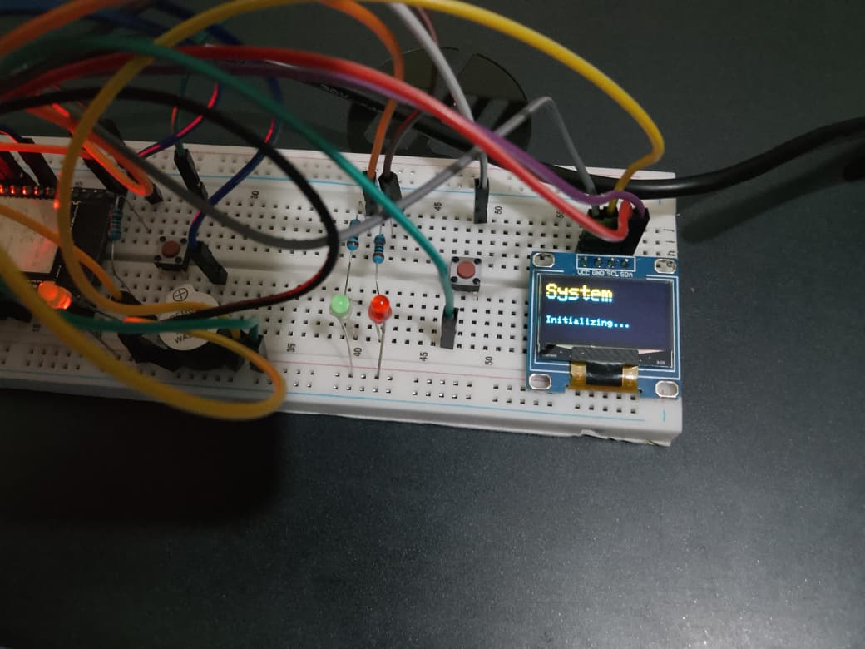

Mode 1:
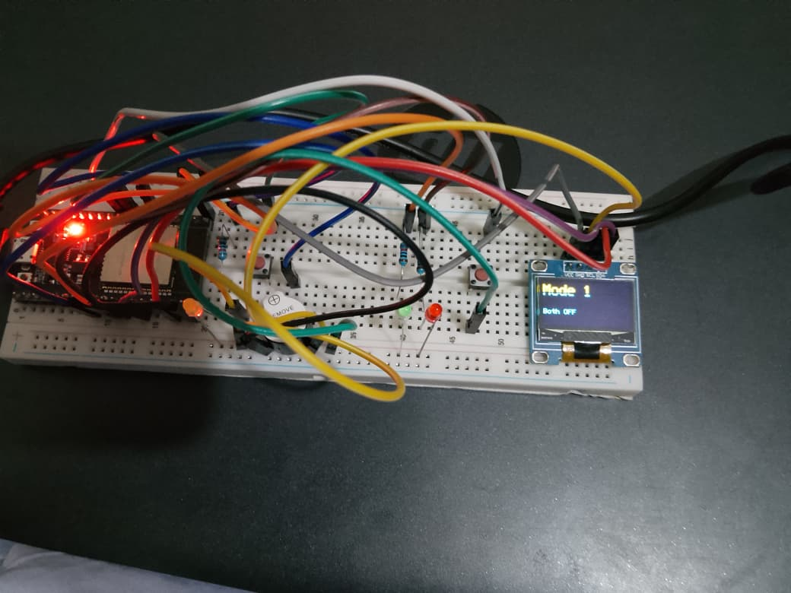

Mode 2:
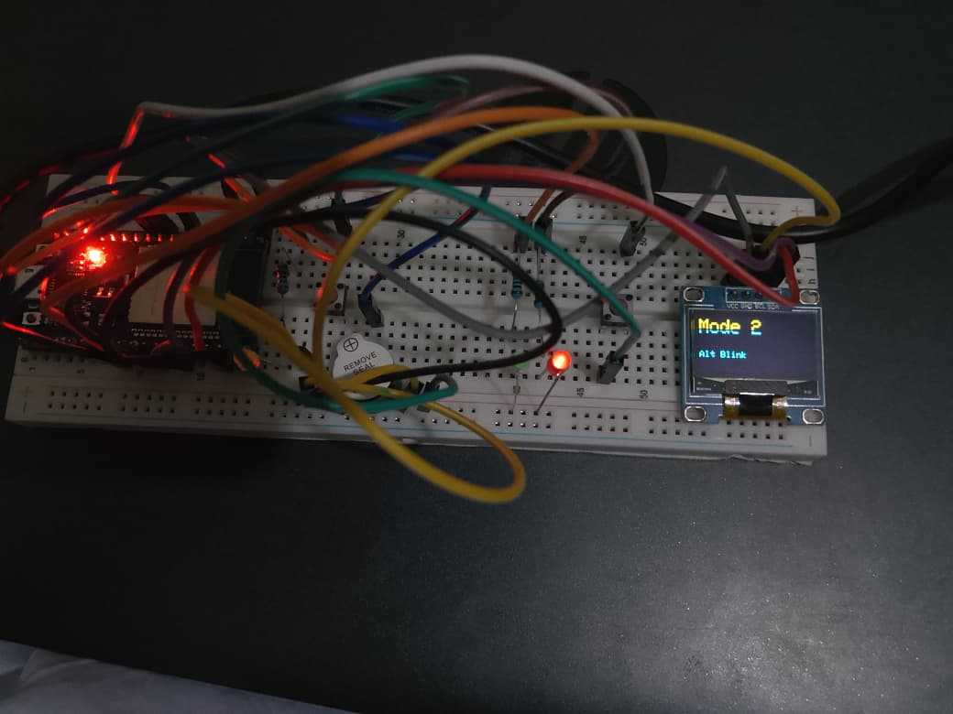

Mode 3:
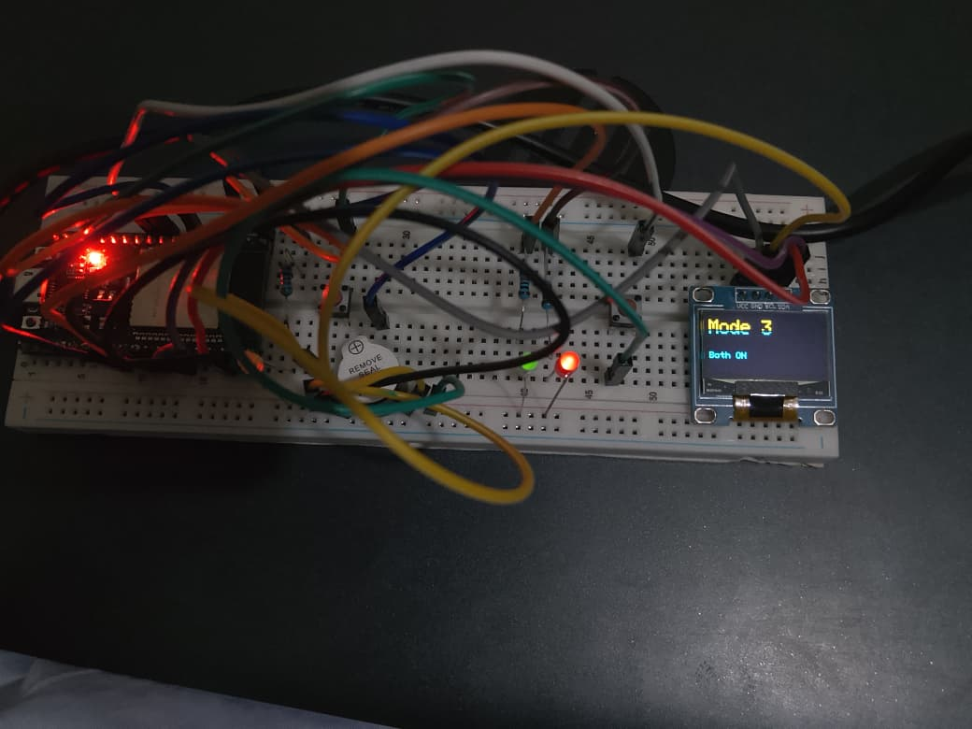

Mode 4:
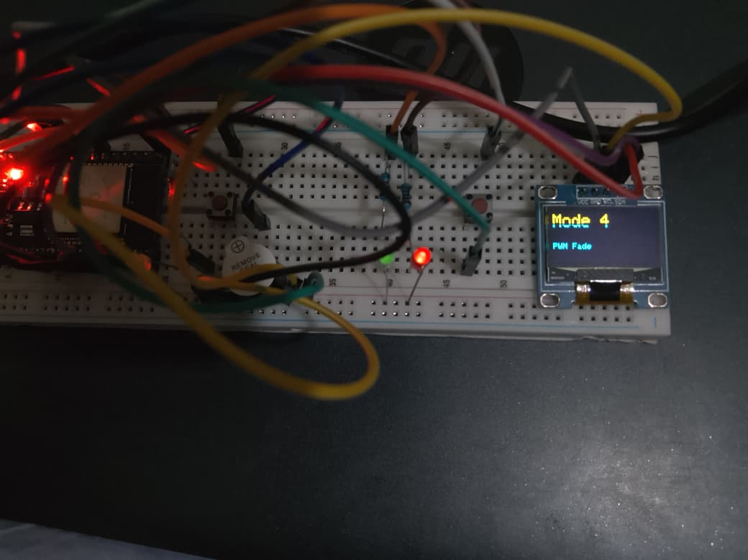

Reset (Boot) Button:
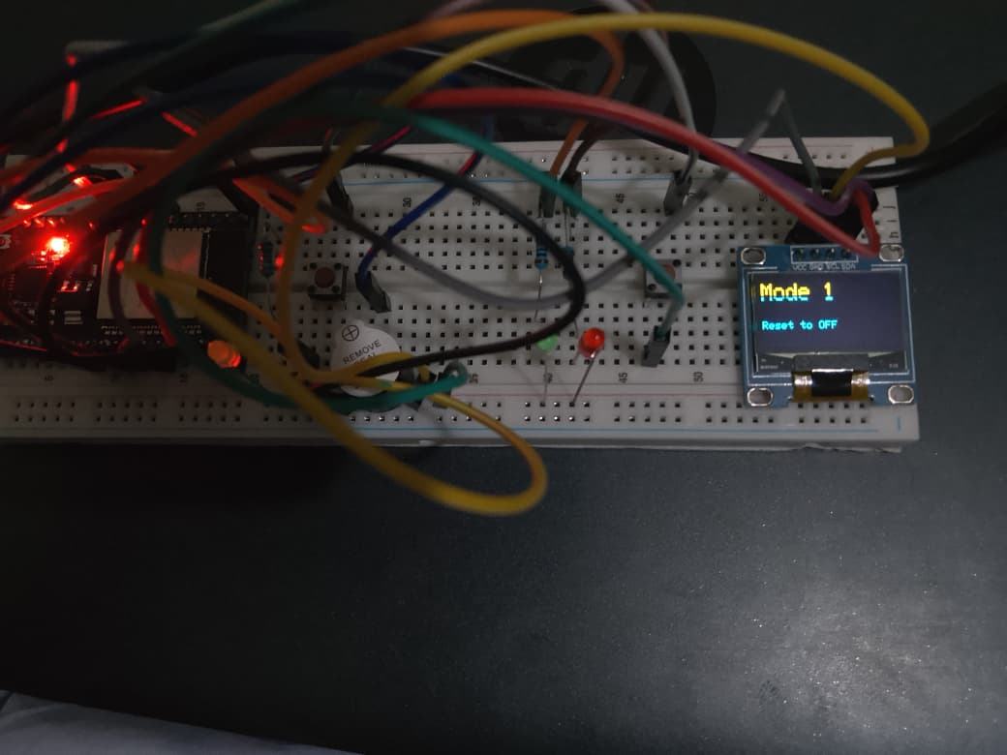

Short Press OFF:
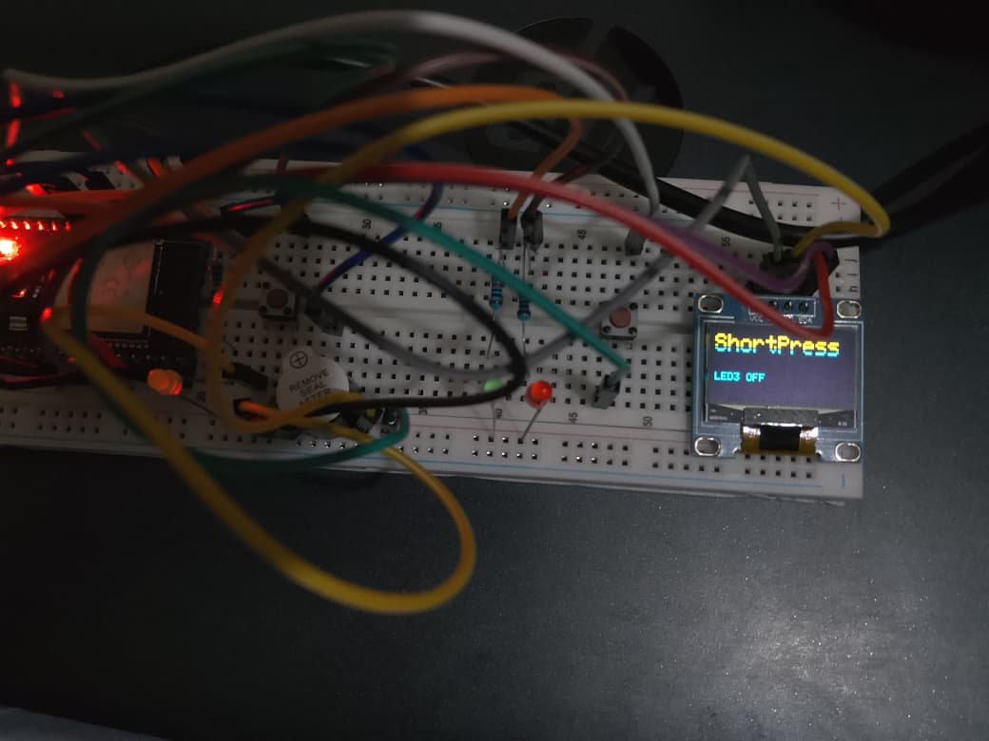

Short Press ON:
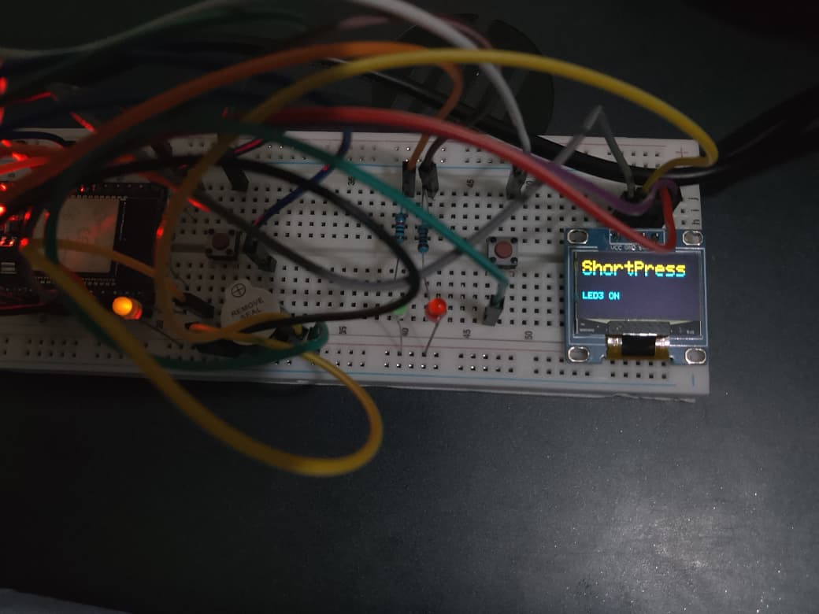

Long Press (>1.5 sec):
